**<https://ayojok.com>**

**New Report [4-3-2019]**

**User-end**

1. Confirm query notification. [solved]
2. MyVendors => this is totally different tables. It should come from confirm order table. After confirmation.
3. Order-list + personal information [Header background + Ayojok logo not visible.] [solved]
4. Add my vendor [ advance payment (Spelling mistake) ] [solved]
5. SSL Payments [ return to the 3 pages ]
   1. Success [solved]
   2. Fail
   3. Cancel
6. Contact number must add before any booking query [if any user not set it previously.] [solved]
7. Payment complete now button. [ payment button should directly redirect to ssl ].
8. Design Booking query larger or set size as screen size/ resolution.
9. Wish-list starting price [N/A] it should show all the starting price.
10. Home page => “load more” button [should be load in the same page] [Solved]
11. Ayojok services every category’s single layout will be different from each other’s. [Time needed]
12. Ayojok journey changed => confirm order => order list => confirm => …………..

**Admin-end**

1. Order-list
   1. Seen /unseen confusing. [solved]
   2. Order delivery dates descending [not solved] [this is actually user group wise ]
   3. Order detail table column’s should be deeper & detail including SSL payment/ transaction information.

**Report as a tester**

1. New Add:
   1. Google Analytics dashboard. [not done] [Stopped by sharif bhai]
   2. SSL Payments. [done]
2. Update:

**User’s-end:**

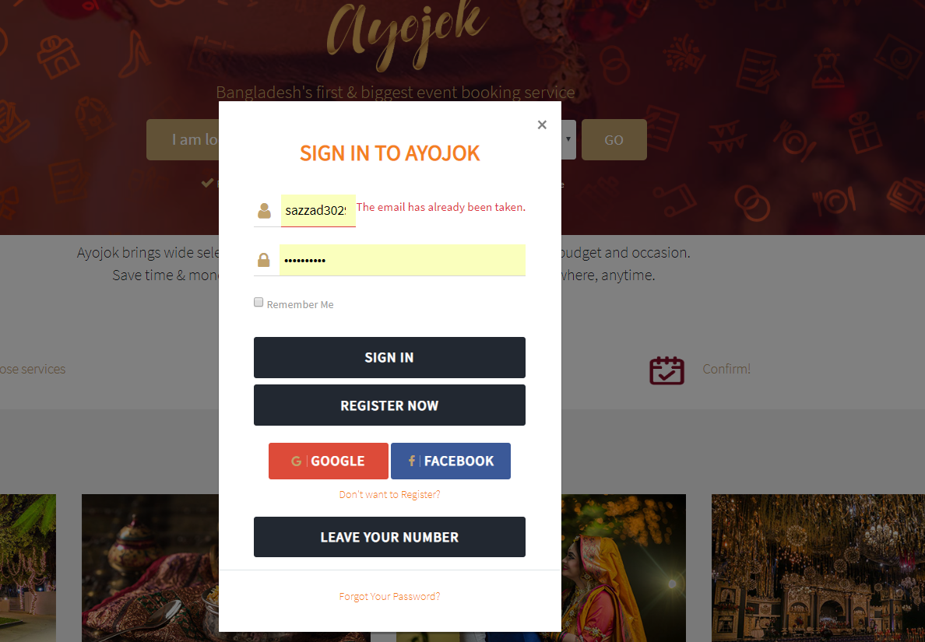

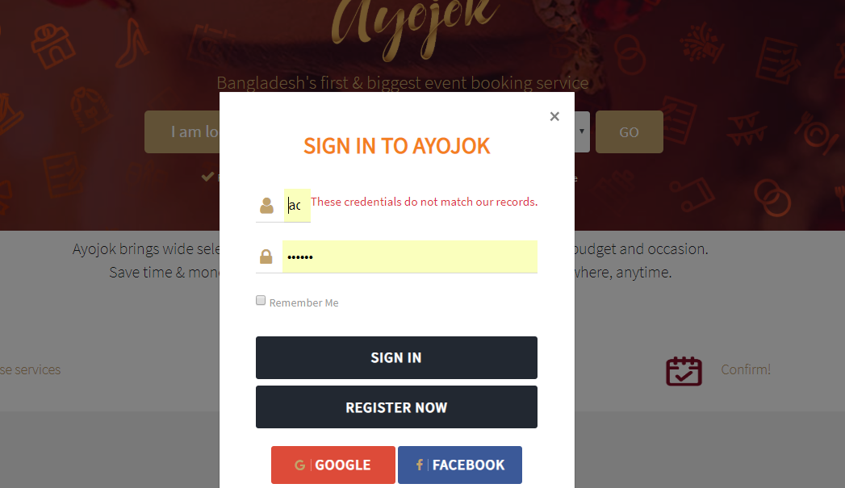

This error message show until new reload the whole page. [Solved]

**Login**:

1. **Facebook login**: ok
2. **Google login**: Irregular behavior [sometimes perfectly login, sometimes not.]
   1. Sign up problem [don’t give permission to new user]
      1. Cause still undefined.
   2. Login ok.
3. **Normal login**: ok

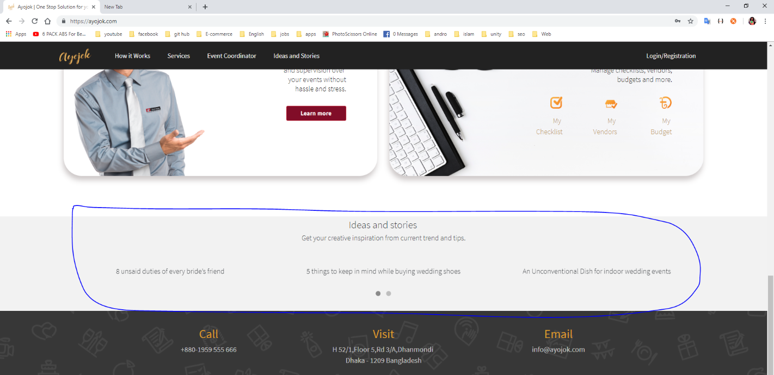

Idea and Stories : Wordpress Blog … [Javed Bhai]

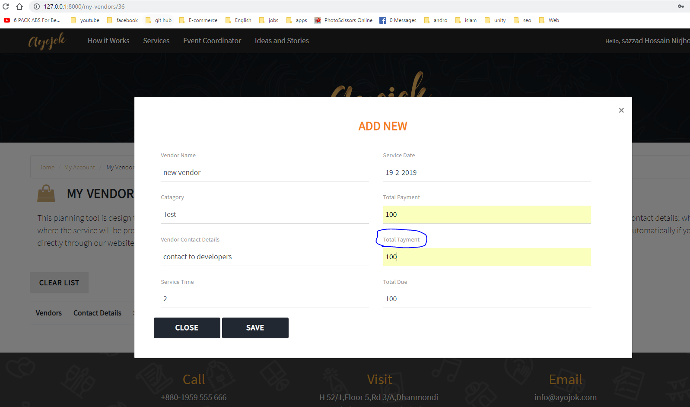

My vendor -> add new vendor? [Need explanation]

My Checklist [explanation]? [How it works I have no idea.]

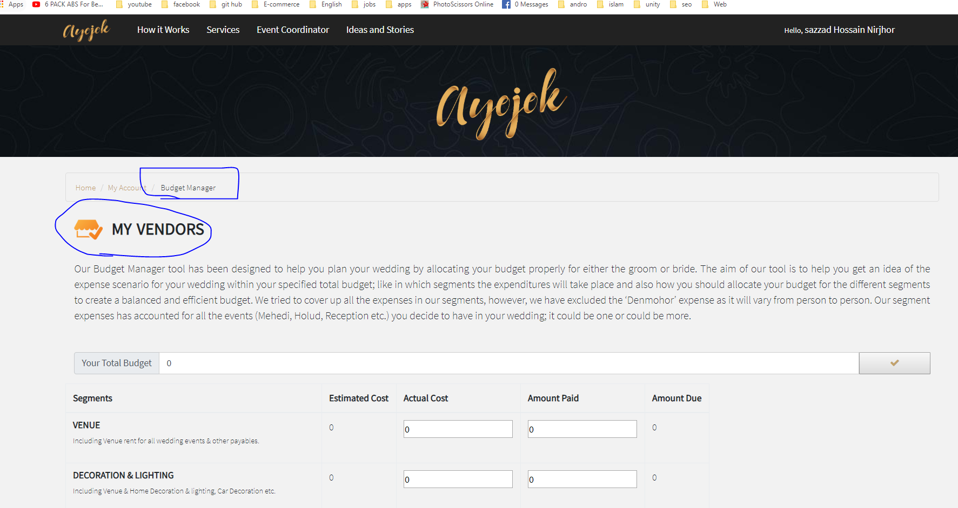

Budget Manager -> [Solved]

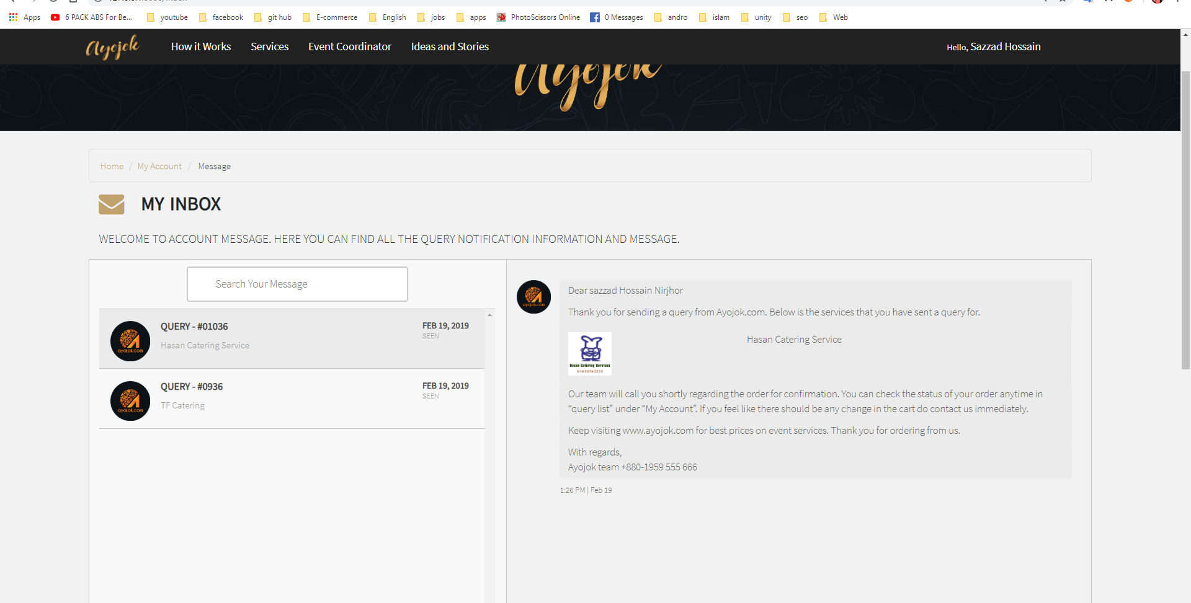

There is no option for deleting user inbox…. [No need to solved – Sajal bhai]

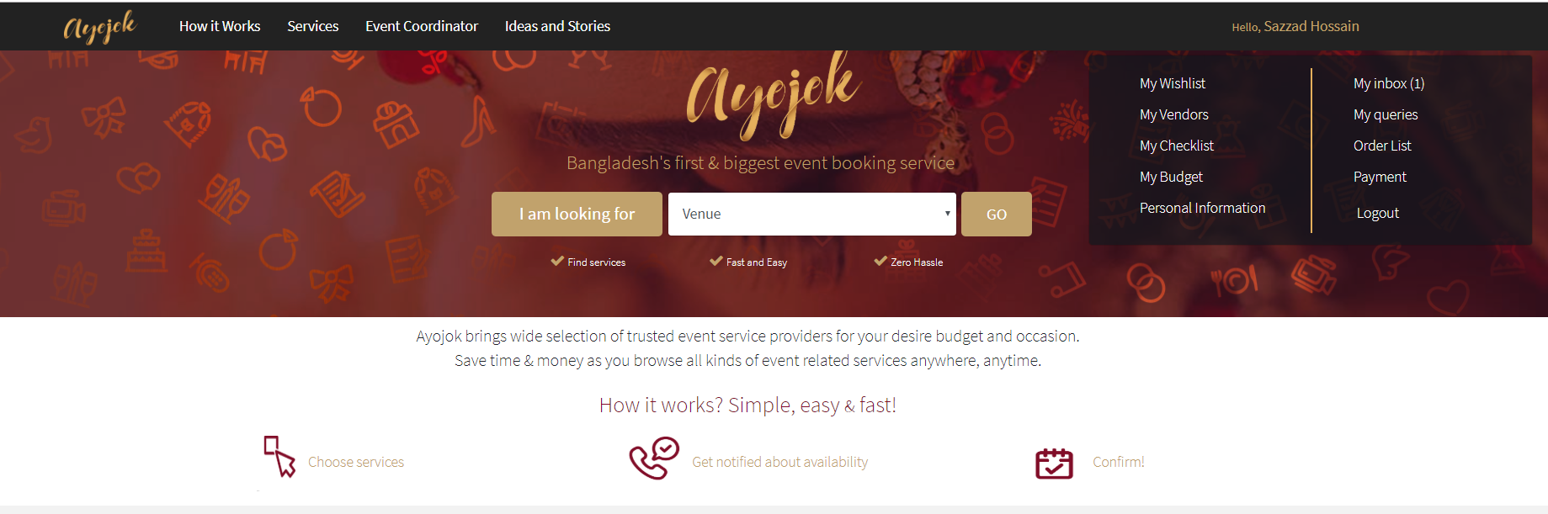

There is no notification system for user to know if admin confirm their query or not? [Solved]

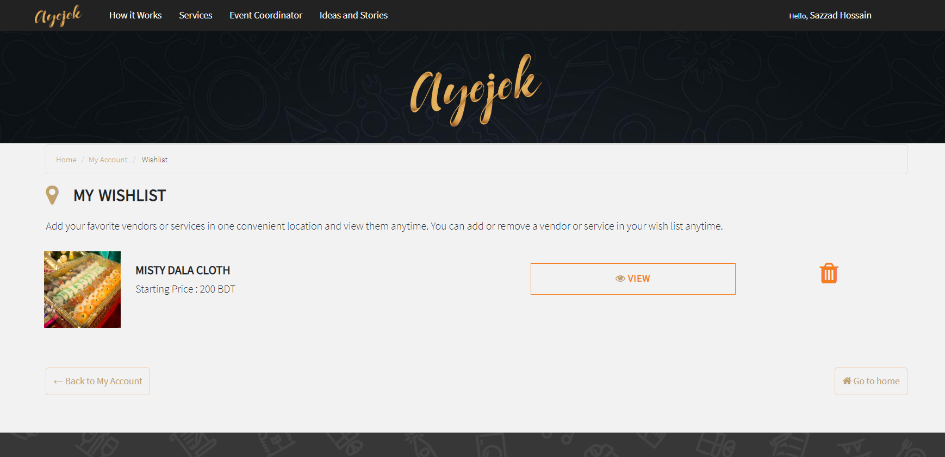

After send the query from the wish list still the list not empty until user delete it personally [No need to solved – Sajal bhai]

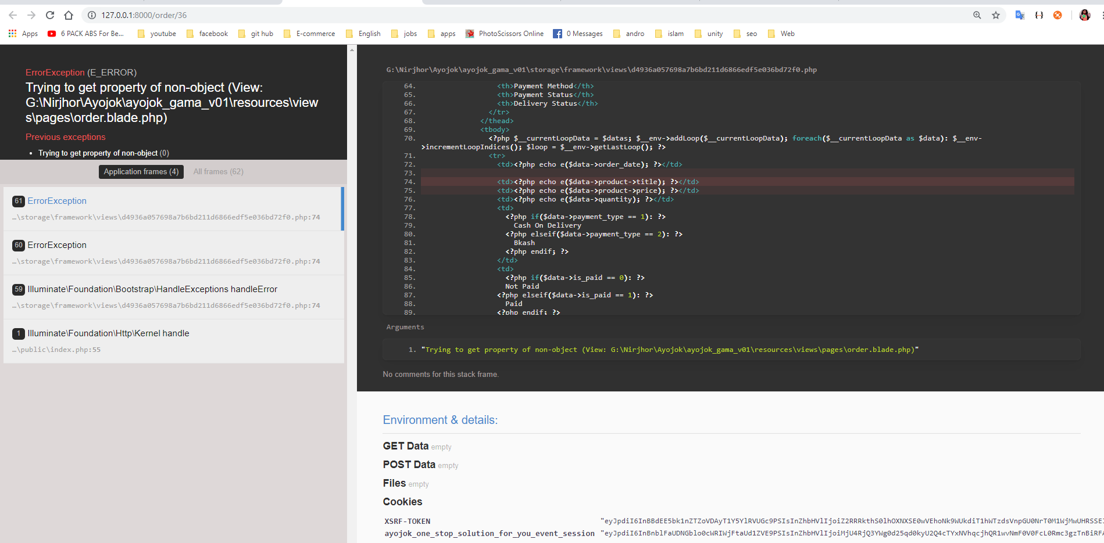

Order list of user. => it is ok when client order any services [Ayojok own] .

No ok when client order any products [any vendor’s product].

[Solved]

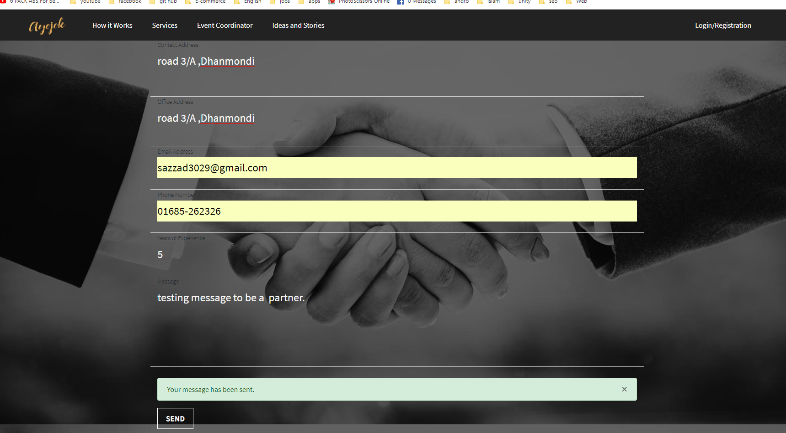

After sending message <https://ayojok.com/partners> page will remain same not reset … [Solved]

**Admin’s-end:**

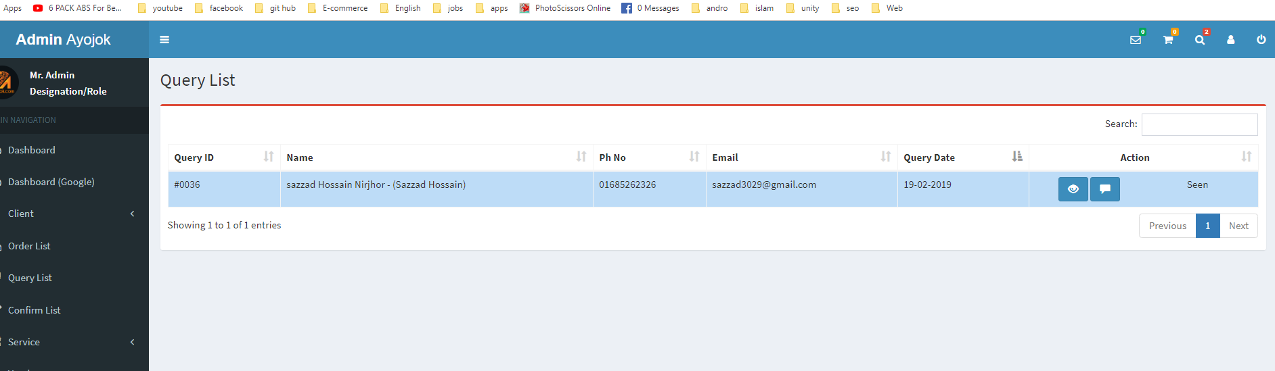

Same user multiple queries send -> seen/Unseen problem. [Solved]

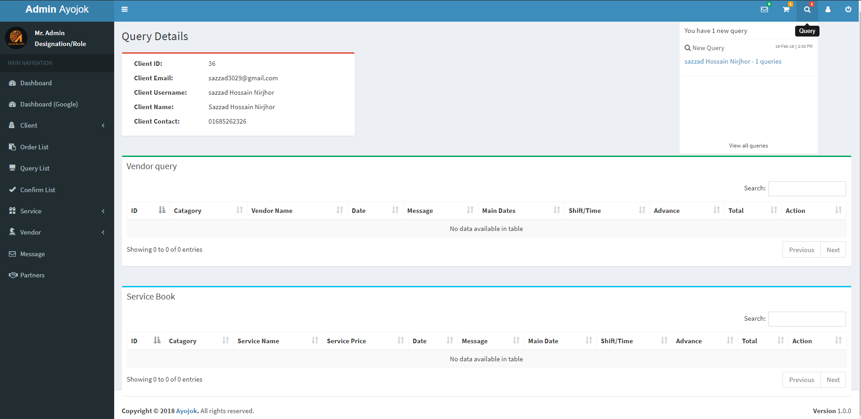

If we confirm any query then it will delete that client from the query list But

When we delete any query then it will not delete that client from the query list. Which makes confusing situation for the admin.

But when client delete that query. It will delete that client from the query list.

[No need to solve – sajal bhai]

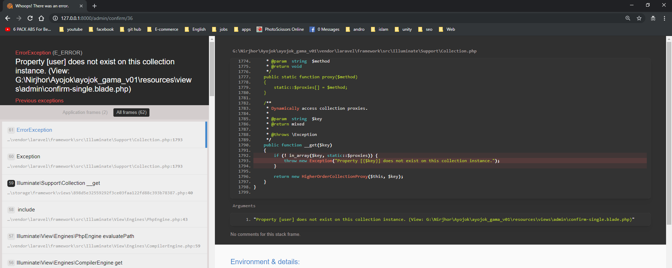

Confirm list => if any client don’t set their first name and last name. Then this error will happened...[Solved]

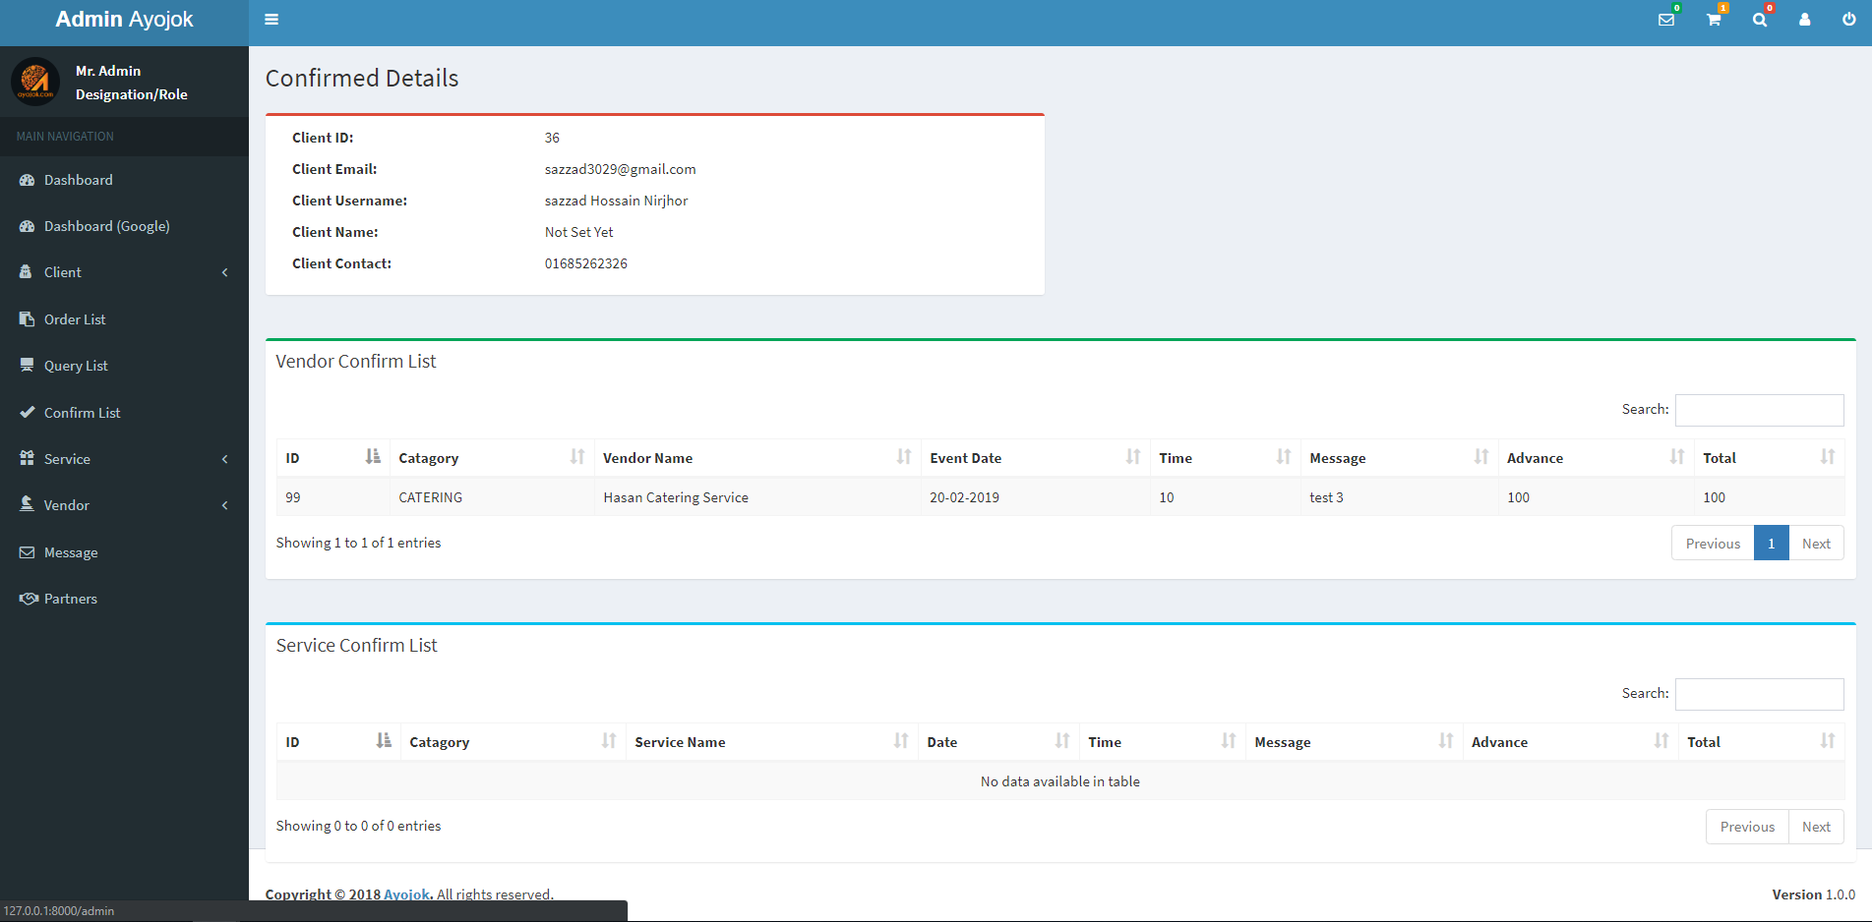

No Action in confirm query detail single.

1. Server Managing:
   1. Data Backup + Image Backup.
   2. Security issues [EX: DDOS Attack Or multi hitting problem from a single device or *IP* ]
   3. …

**Now: what’s next to do [for better performance or view]**

**User-end:**

**Admin-end:**

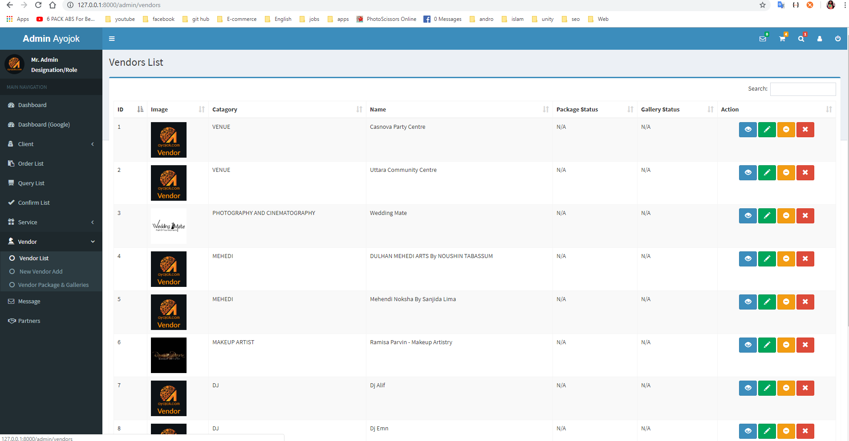

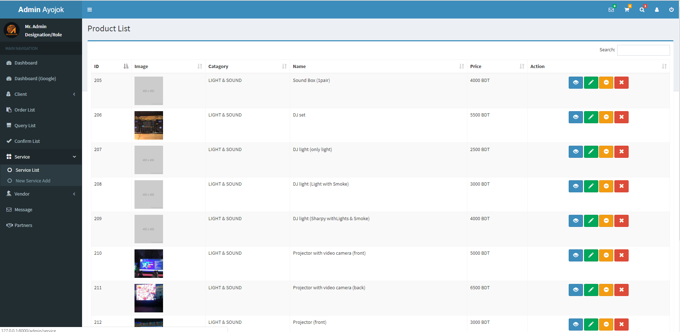

**There is no categorized section for better managements. [Solved ]**